

**INFORMATICS INSTITUTE OF TECHNOLOGY IN COLLABORATION WITH UNIVERSITY OF WESTMINSTER(UOW)**

**B.Eng. (Hons) Software Engineering**

5COSC020W Database Systems

Module Leader: Mr.Ragu Sivaraman

Individual Coursework (Part A )

Intermediary Report: PART I

**Tutorial Group**: G

**UOW ID**: w1898945

**Student ID**: 20211337

**Student Full Name**: Fathima Hasni Maheeza Haleemdeen

**Date of Submission**: 31/10/2022

**Contents**

1. Conceptual ERD diagram for Tourmato…………………………………………….3

2. Data dictionary to justify the entities found for Tourmato…………………….4

3. Data dictionary to justify the identified relationships and multiplicities for TOURMATO……………………….5

4. Data Dictionary to document how you identified the attributes and primary keys for each entity for Tourmato……….7

5. The logical EERD………8

6. SQL Query……..8

7. SQL Query to select the records with the given conditions…..17

**PART A**

1. Conceptual ERD diagram for Tourmato.

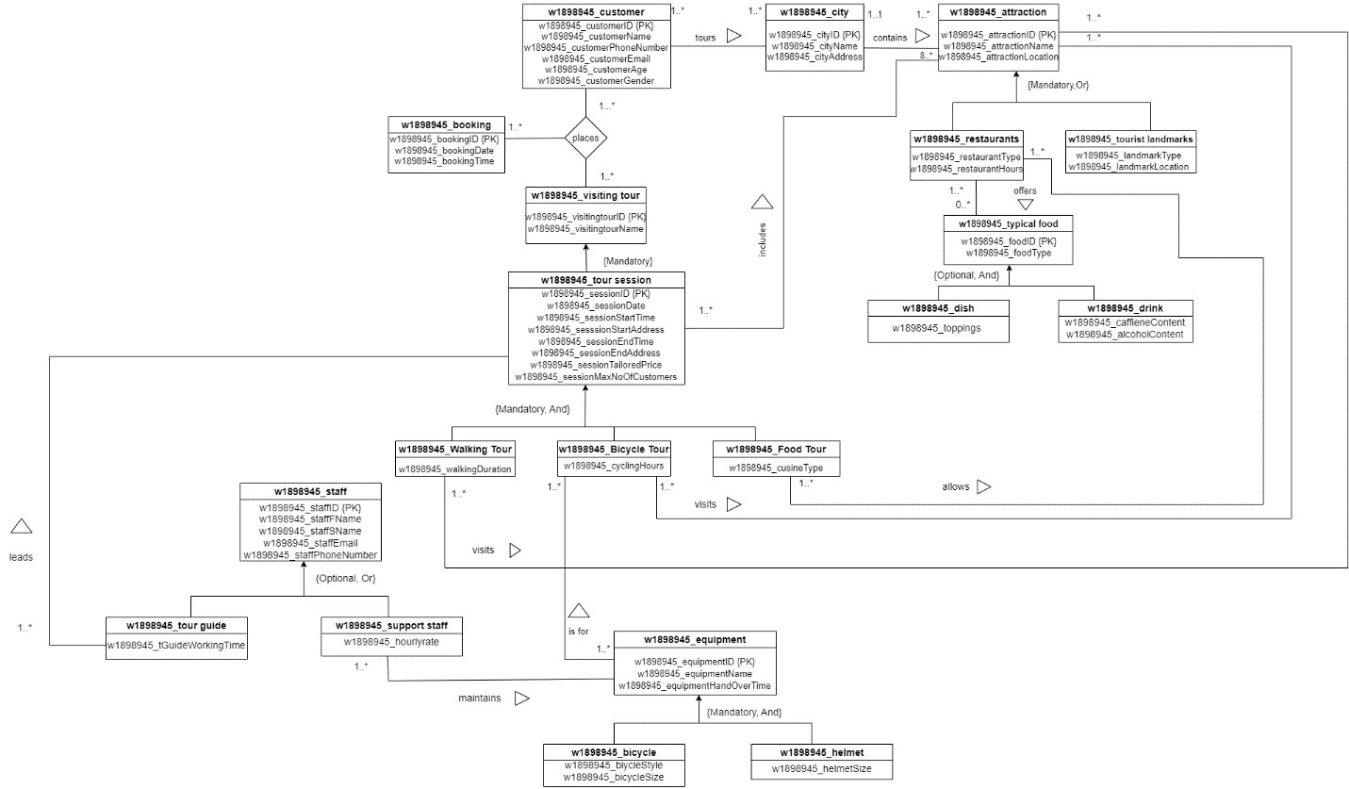

1. **Data dictionary to justify the entities found for TOURMATO.**

|  |  |
| --- | --- |
| **Entity Name** | **Brief Description** |
| w1898945_Customer | This is a general term used to describe a customer in Tourmato who intends to make a visit to the tourist attractions around Europe countries. |
| w1898945_City | This is a general term used to describe a city to experience their unique atmospheres, under the direction of a local experienced tour guide. |
| w1898945_ Attractions | This is a general term used to describe multiple touristic attractions considered worth visiting. |
| w1898945_Visiting Tour | This is a general term used to describe to provide a range of experiences, every city covered by Tourmato |
| w1898945_Tour Guide | This is a general term used to describe naturally to lead the tour sessions: they take the customers around the city, stop at every attraction, and enthusiastically narrate key facts on the history, geography, architecture, ecology, or gastronomy for each visited attraction. |
| w1898945_Tourist Session | This is a general term used to describe a visiting tour that has been assigned a specific start date and time, a start address, an end date and time and an end address. Every tour session is also given a tailored price and a maximum number of customers that it can accommodate. |
| W1898945_Staff | This is a general term used to describe highly-trained employees with specialized roles at Tourmato. |

|  |  |  |
| --- | --- | --- |
| **General Entity** | **Specialised Entity** | **Explanation** |
| w1898945_Equipment | w1898945_bicycle  w1898945_helmet | This is a general term used to describe cycling session where Tourmato lends two main types of equipment for cycling tour sessions: bicycles and cycle helmets. Bicycles come in several styles and sizes, while helmets also have different sizes |
| w1898945_Typical Food | w1898945_dishes  w1898945_drinks | This is a general term used to describe food tour session allow customers to stop at different restaurants and sample selected foods i.e., several dishes and/or drinks. It is possible for a walking tour session or a cycling tour session to also be a food tour session: in this case, customers will walk or ride between different attractions, see selected landmarks and stop at different restaurants to taste some of the nice foods on offer. |
| w1898945_Staff | w1898945_tour guide  w1898945_support staff | The job of tour guides is naturally to lead the tour sessions: they take the customers around the city, stop at every attraction, and enthusiastically narrate key facts on the history, geography, architecture, ecology, or gastronomy for each visited attraction. Support staff also play a key role by ensuring the strict maintenance of all equipment used by Tourmato. Each member of the support staff is assigned the responsibility of several pieces of equipment to ensure that they are always kept in great condition. |
| w1898945_Tour Session | w1898945_walking tour  w1898945_bicycle tour  w1898945_food tour | Walking tour sessions are conducted on foot: customers visit the city by walking from one attraction to another. On cycling tour sessions, customers ride from one attraction to another on a bicycle. Finally, food tour sessions allow customers to stop at different restaurants and sample selected foods i.e., several dishes and/or drinks. It is possible for a walking tour session or a cycling tour session to also be a food tour session: in this case, customers will walk or ride between different attractions, see selected landmarks and stop at different restaurants to taste some of the nice foods on offer |
| w1898945_Attractions | w1898945_tourist landmarks  w1898945_restaurants | Landmarks are simply relevant locations in the city that can be viewed, such as monuments, buildings, statues, squares, streets, parks, places of worship and so many more. Restaurants, on the other hand, offer interesting typical foods (dishes and/or drinks) to be sampled so that to allow people to experience the local culinary delicacies. |

1. **Data dictionary to justify the identified relationships and multiplicities for TOURMATO.**

|  |  |  |  |  |  |
| --- | --- | --- | --- | --- | --- |
| **Entity name** | **Multiplicity** | **Relationship** | **Multiplicity** | **Entity name** | **Brief justifications for the multiplicity (4 statements for each relationship)** |
| w1898945_Customer | 1.. * | Tours | 1.. * | City | |  | | --- | | Customer tours at least one city. | | One customer tour many cities. | | One city can be toured by at least one customer. | | One city can be toured by many customers. | |
| w1898945_City | 1..1 | Contains | 1.. * | w1898945_attractions | |  | | --- | | One city contains at least one tourist attraction. | | One city contains many tourist attractions. | | One tourist attraction can contain one city. | | One tourist attraction can contain maximum of one city. | |
| w1898945_Tour session | 1.. * | Includes | 8.. * | w1898945_attractions | |  | | --- | | One tour session includes at least one tourist attraction. | | One tour session includes many tourist attractions. | | One tourist attraction can include one tour session. | | One tourist attraction can include maximum of one tour session. | |
| w1898945_Tour guide | 1.. * | Leads | 0.. * | w1898945_Tour Session | |  | | --- | | Tour guide leads at least one tour session. | | One Tour guide leads many tours session. | | One Tour session lead by a tour guide. | | One tour session can be led by a maximum of one tour guide. | |
| w1898945_Restaurants | 1.. * | Offers | 0.. * | w1898945_Typical Food | |  | | --- | | One restaurant offers at least one type of food. | | One restaurant offers many types of food. | | A particular food offered by at least one restaurant. | | A particular food can be offered by a maximum of one restaurant. | |
| w1898945_Support Staff | 1.. * | Maintains | 1.. * | w1898945_Equipment | |  | | --- | | One support staff maintains at least one equipment. | | One support staff maintains many equipment. | | An equipment is maintained by at least one support staff | | An equipment can be maintained by a maximum of one support staff. | |
| w1898945_Bicycle Tour | 1.. * | Visits | 1.. * | W1898945_Attractions | |  | | --- | | One bicycle tour visits at least one attraction location. | | One bicycle tour can visit many attractions location. | | An attraction location is visited by at least one bicycle tour. | | An attraction location can be visited by a maximum of one bicycle tour. | |

1. **Data Dictionary to document how you identified the attributes and primary keys for each entity for Tourmato.**

|  |  |  |
| --- | --- | --- |
| **Entity name** | **Attributes for this entity (include PK)** | **Brief explanation** |
| w1898945_Customer | |  | | --- | | w1898945_customerID {PK} | | w1898945_customerName | | w1898945_customerAddress | | w1898945_customerPhoneNumber | | |  | | --- | | Uniquely identifies a customer and this is the primary key for the customer entity. (Primary key) | | Defines the name of customer | | Defines the information of the customer’s address. | | Defines the contact number of the customer. | |
| w1898945_City | |  | | --- | | w1898945_cityID {PK} | | w1898945_cityName | | w1898945_cityAddress | | |  | | --- | | Uniquely identifies a city and this is the primary key for the city entity. (Primary key) | | Defines the name of city. | | Defines the information of the city’s address | |
| w1898945_Tour session | |  | | --- | | w1898945_sessionID {PK} | | w1898945_sessionDate | | w1898945_sessionStartTime | | w1898945_sessionStartAddress | | w1898945_sessionEndTime | | w1898945_sessionEndAddress | | w1898945_sessionTailoredPrice | | |  | | --- | | Uniquely identifies a session and this is the primary key for the session entity. (Primary key) | | Defines the confirmed date of session. | | Defines the confirmed start time of session. | | Defines the confirmed start address of session. | | Defines the confirmed end time of session. | | Defines the confirmed end time of session. | | Defines the confirmed tailored price of session. | |
| w1898945_Staff | |  | | --- | | w1898945_staffID {PK} | | w1898945_staffFName | | w1898945_staffSName | | w1898945_staffEmail | | w1898945_staffPhoneNumber | | |  | | --- | | Uniquely identifies a staff and this is the primary key for the staff entity. (Primary key) | | Defines the First name of staff. | | Defines the Surname name of staff. | | Defines the Email of staff. | | Defines the contact number of the staff. | |
| w1898945_Equipment | |  | | --- | | w1898945_equipmentID {PK} | | w1898945_equipmentName | | w1898945_equipmentHandOverTime | | |  | | --- | | Uniquely identifies an equipment and this is the primary key for the equipment entity. (Primary key) | | Defines the name of the equipment. | | Defines the due time of the equipment. | |
| w1898945_typical food | |  | | --- | | w1898945_foodID {PK} | | w1898945_food type | | |  | | --- | | Uniquely identifies a food and this is the primary key for the food entity. (Primary key) | | Defines the different types of food. | |
| w1898945_Attractions | |  | | --- | | w1898945_attractionID {PK} | | w1898945_attractionName | | w1898945_attractionLocation | | |  | | --- | | Uniquely identifies an attraction and this is the primary key for the attraction entity. (Primary key) | | Defines the name of an attraction. | | Defines the location of an attraction. | |

|  |  |  |  |  |  |  |  |  |
| --- | --- | --- | --- | --- | --- | --- | --- | --- |
| w1898945_Booking | |  | | --- | | w1898945_bookingID {PK} | | w1898945_bookingDate | | w1898945_bookingTime | | |  | | --- | | Uniquely identifies the booking of the tour and this is the primary key for the booking entity. (Primary key) | | Defines the date of booking of the tour. | | Defines the time of booking of the tour. | |
| w1898945_Visiting Tour | |  | | --- | | w1898945_visiting tourID {PK} | | w1898945_visiting tourName | | |  | | --- | | Uniquely identifies the visiting tour and this is the primary key for the visiting tour. (Primary key) | | Defines the name of the visiting tour. | |

1. **THE LOGICAL EERD**

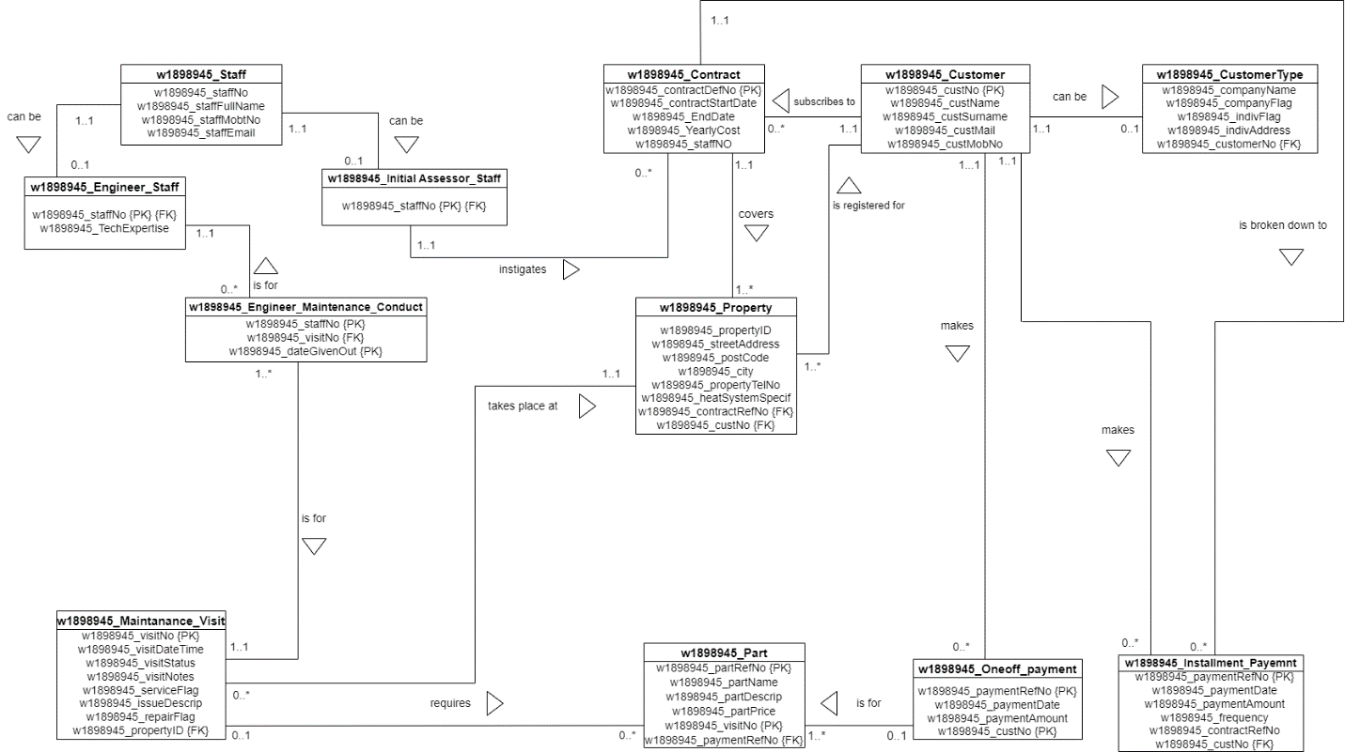

1. **SQL QUERY**
2. **Creating Database**

Code > CREATE DATABASE w1898945_coursework;

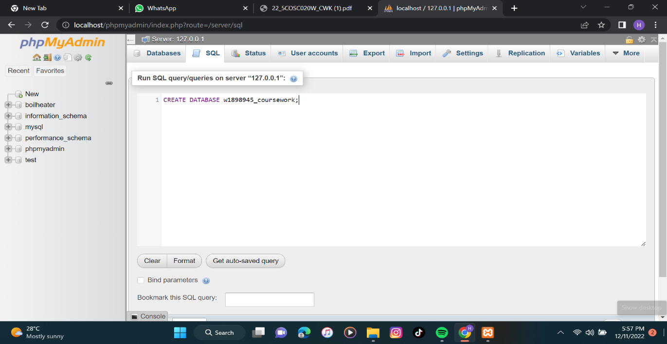

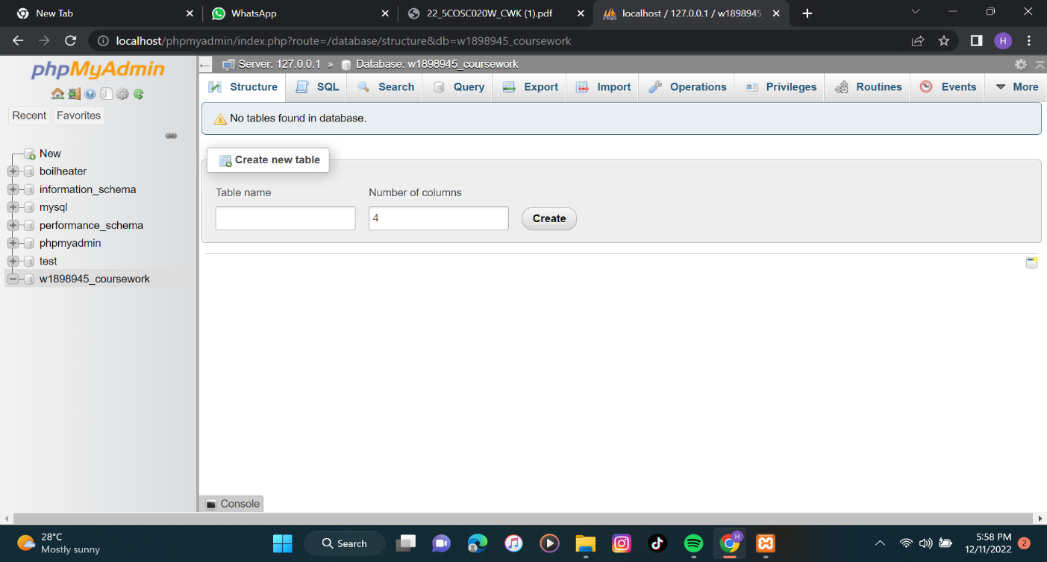

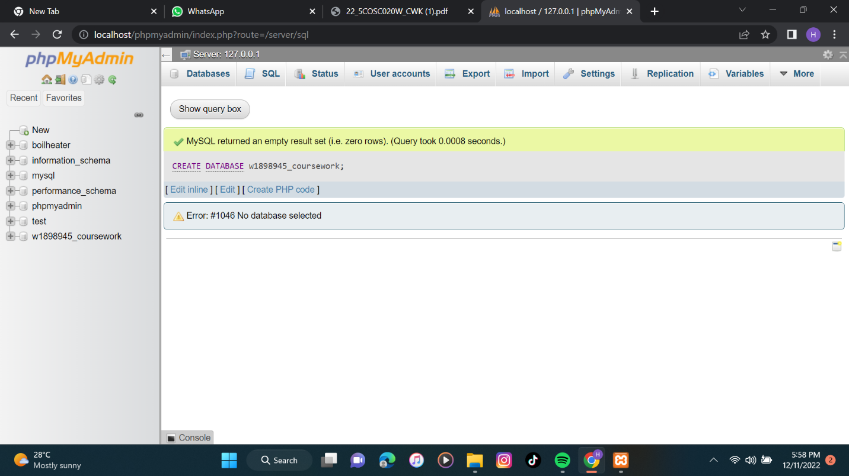

1. **Creating the tables and populating the tables.**

CREATE TABLE w1898945_Customer

(

w1898945_custNo INT,

w1898945_custName VARCHAR (40) NOT NULL,

w1898945_custSurname VARCHAR (80) NOT NULL,

w1898945_custEmail VARCHAR (80) NOT NULL,

w1898945_custMobNo TEGER NOT NULL,

CONSTRAINT c_cNo_pk PRIMARY KEY(w1898945_custNo)

);

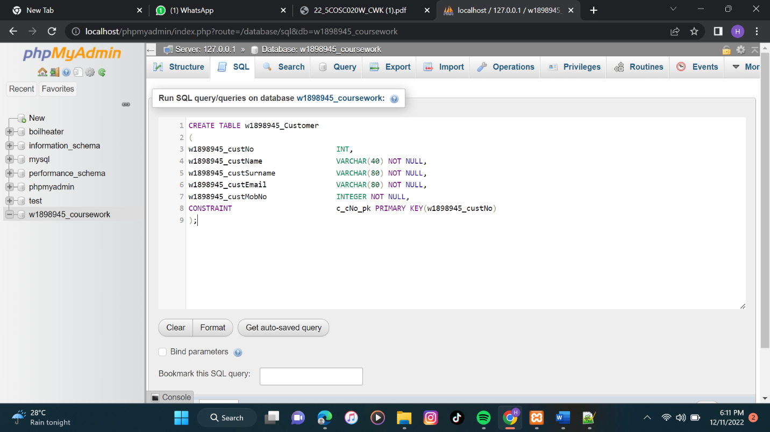

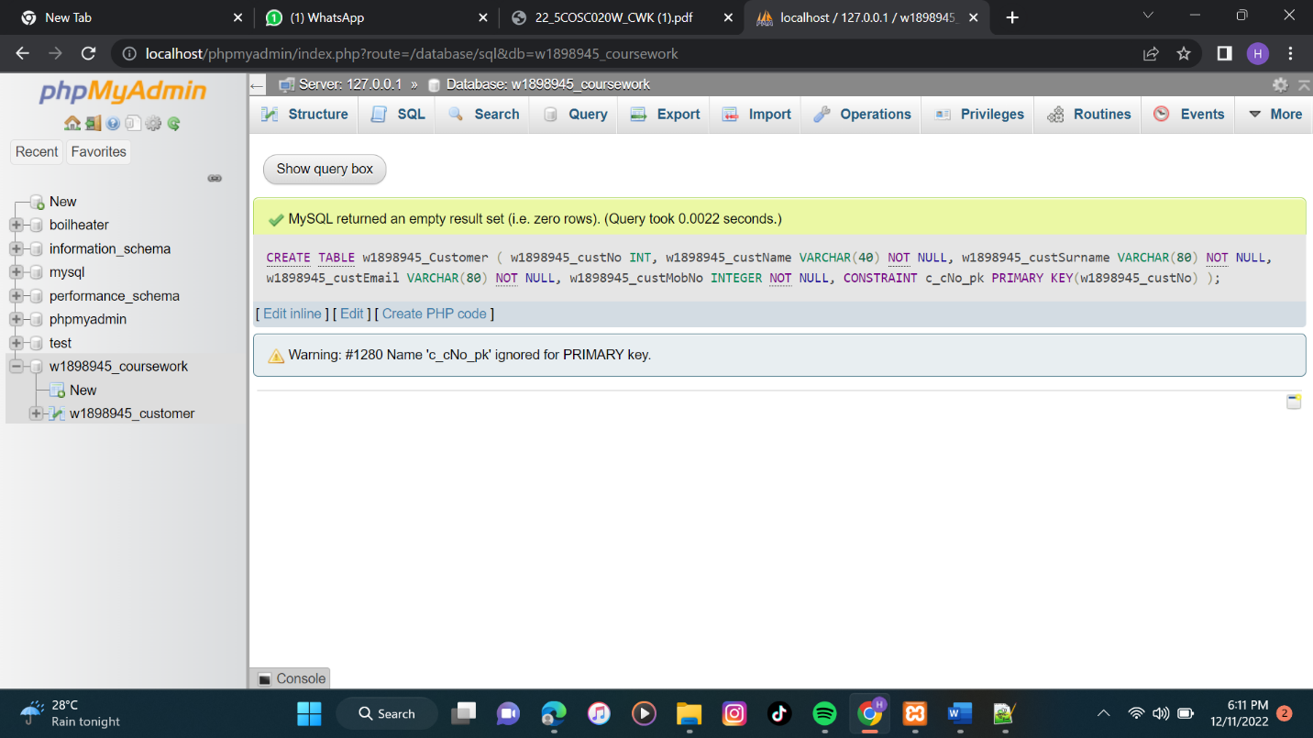

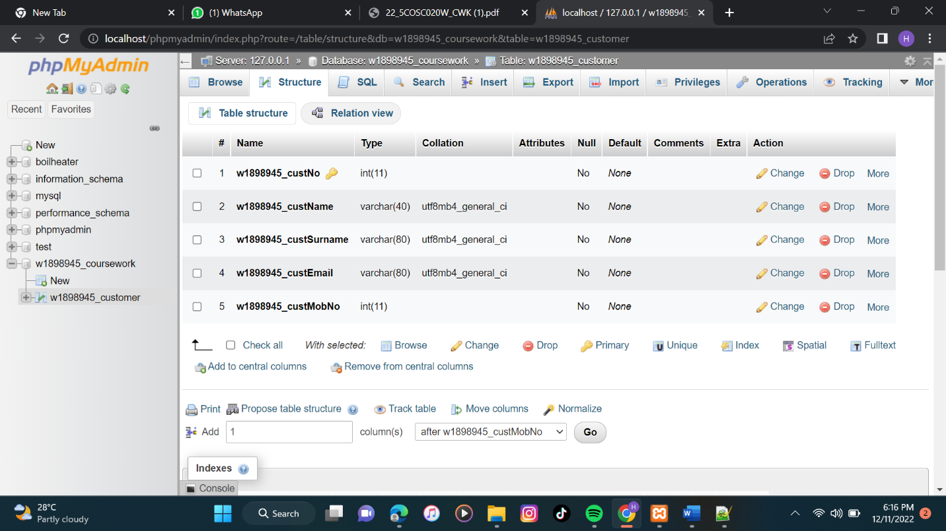

Code > INSERT INTO w1898945_customer (w1898945_custNo,w1898945_custName,w1898945_custSurname,w1898945_custEmail,w1898945_custMobNo)

VALUES('01','deverakonda','vijay','thedeverakonda@gmail.com','0923451004'),

('02','peter','parker','ptrparker@gmail.com','0856732879'),

('03','hasni','haleem','hashal@gmail.com','0789045123'),

('04','arjun','reddy','arjunreddy17@gmail.com','0913458944'),

('05','shreya','goshal','shregoshal145@gmail.com','0768901123'),

('06','ar','rahman','arrahman@gmail.com','0873547208'),

('07','selena','gomez','selgomez95@gmail.com','0987564356'),

('08','ayaan','thariq','thariqayaan02@gmail.com','0112347802'),

('09','amaani','raazil','raazilamaani@gmail.com','0745670987'),

('10','omar','abbas','omarabbas78@gmail.com','0935640077');

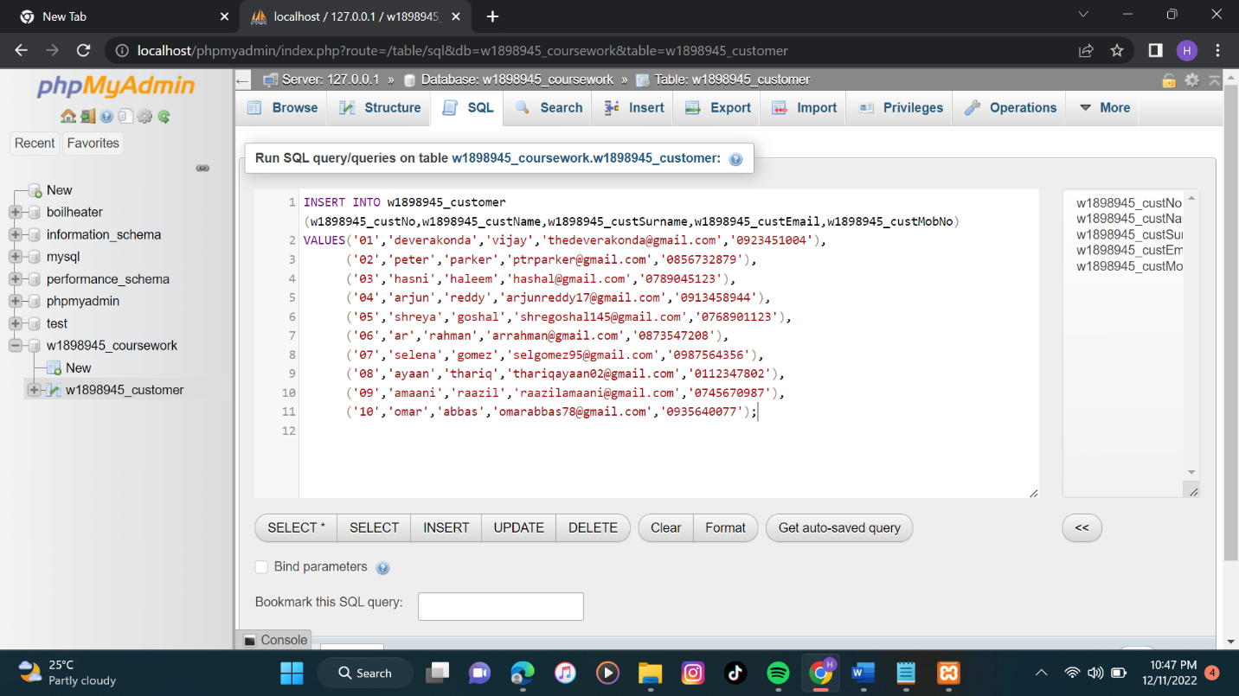

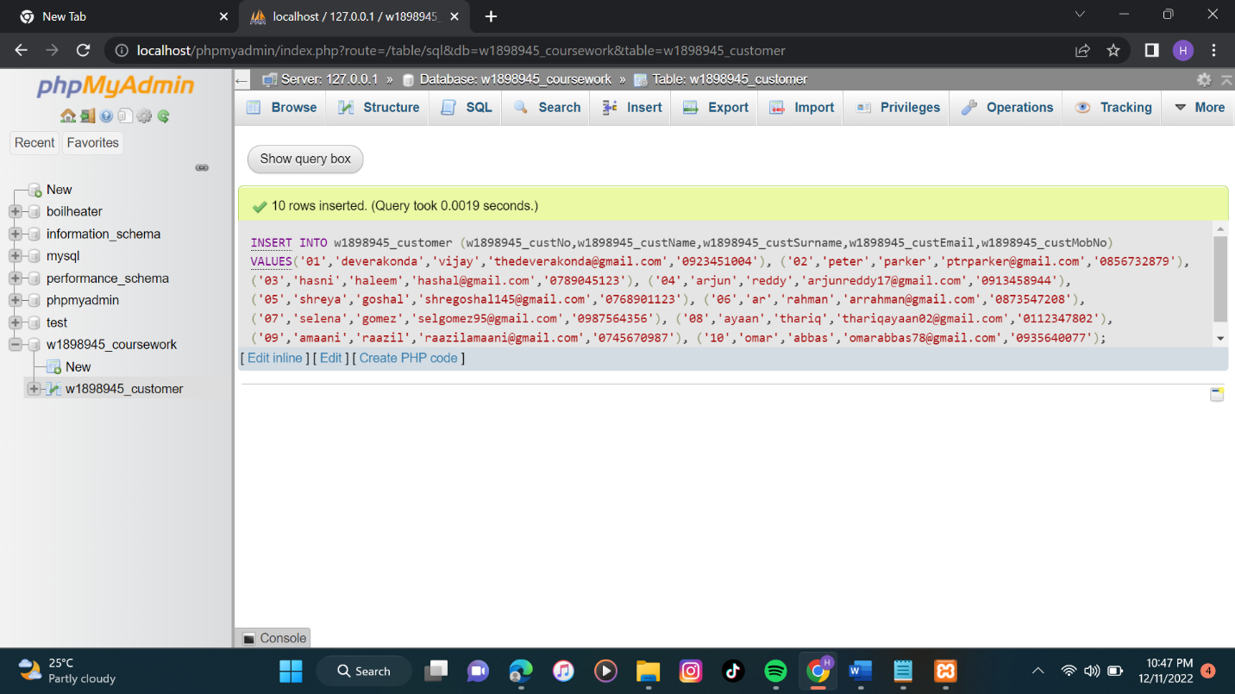

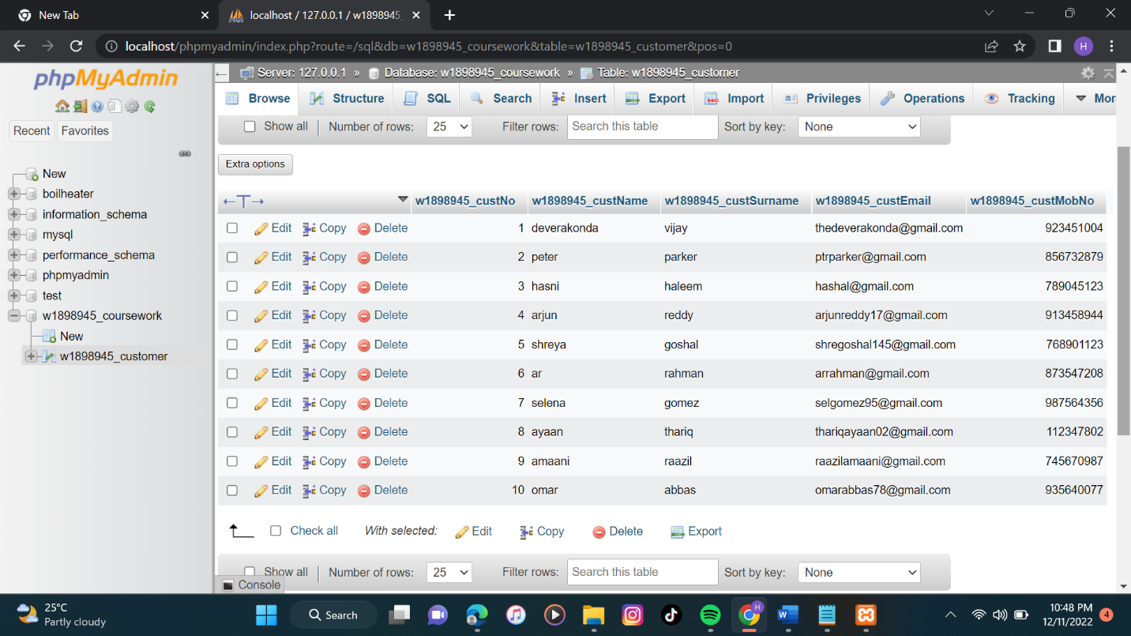

1. **Creating Oneoff_payment table and populating the table.**

CREATE TABLE w1898945_Oneoff_Payment

(

w1898945_paymentRefNo INT,

w1898945_paymentDate date,

w1898945_paymentAmount DECIMAL(7,2),

w1898945_custNo INT NOT NULL,

constraint o_op_pk PRIMARY KEY (w1898945_paymentRefNo),

constraint c_cNO_fk FOREIGN KEY (w1898945_custNo)

references w1898945_customer(w1898945_custNo)

);

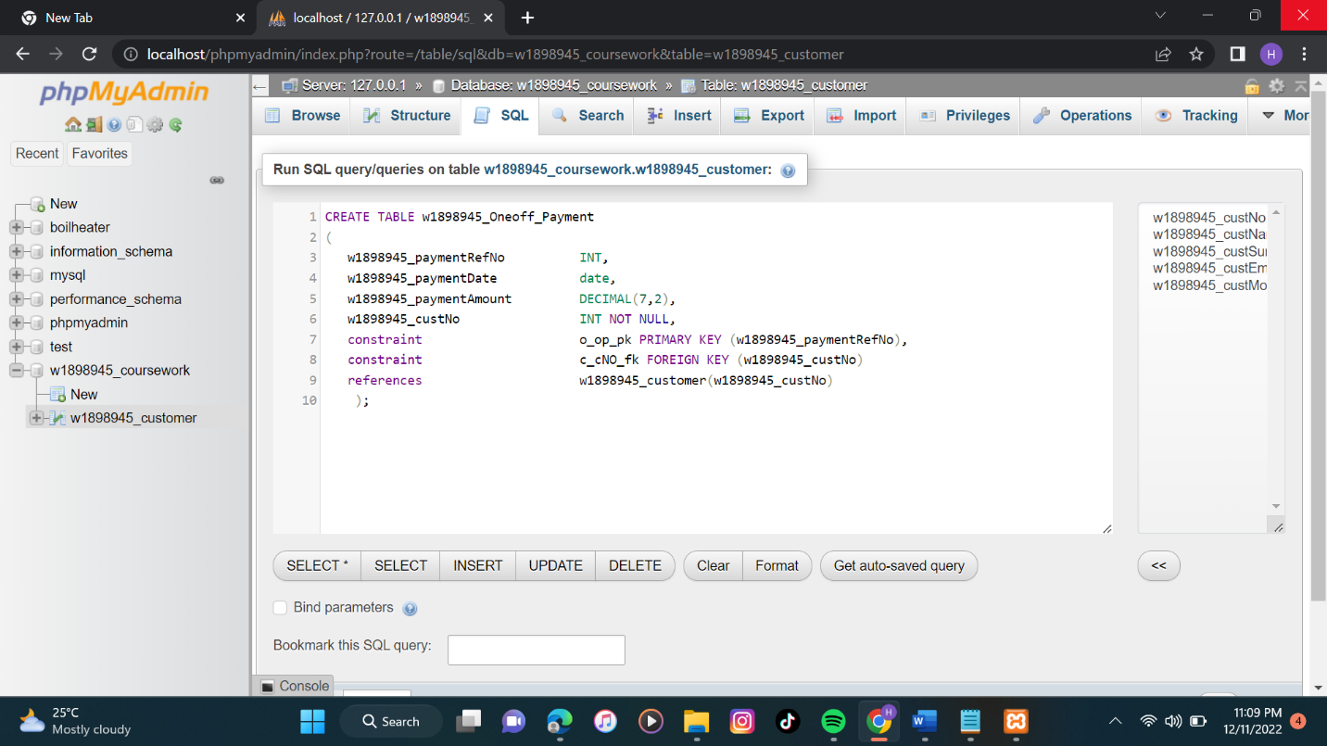

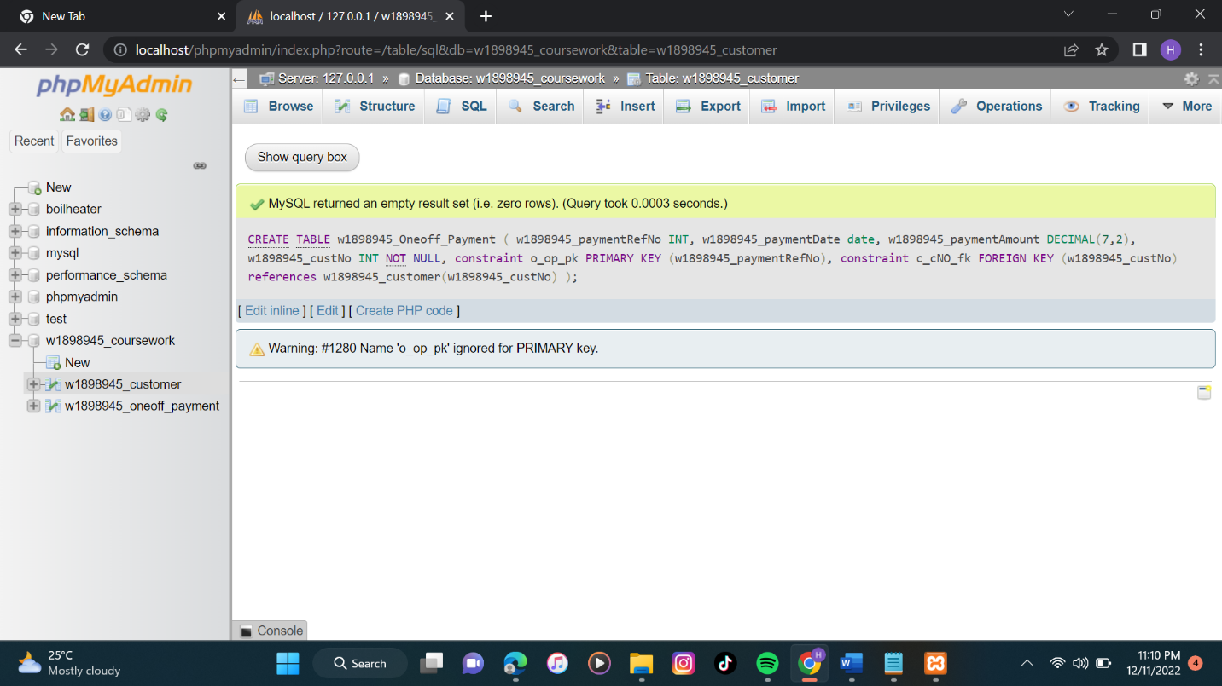

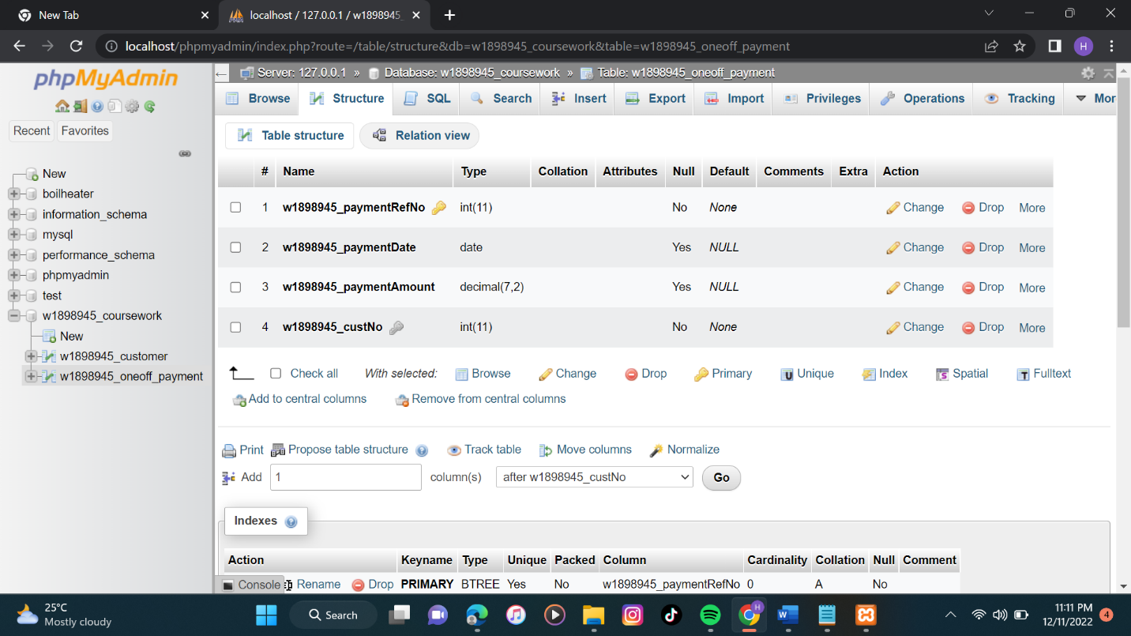

INSERT INTO

w1898945_oneoff_payment(w1898945_paymentRefNo,w1898945_paymentDate,w1898945_paymentAmount,w1898945_custNo)

VALUES ('101','2021-10-21','57.00','01'),

('102','2021-12-06','89.00','02'),

('103','2022-05-05','44.00','03'),

('104','2022-07-09','77.00','04'),

('105','2022-02-14','36.00','05'),

('106','2022-10-19','69.00','06'),

('107','2022-04-25','99.00','07'),

('108','2022-12-13','45.00','08'),

('109','2022-09-05','53.00','09'),

('110','2022-03-23','83.00','10');

SELECT w1898945_custSurname,w1898945_custEmail,w1898945_paymentRefNo,w1898945_paymentAmount

FROM w1898945_customer JOIN w1898945_oneoff_payment

ON w1898945_customer.w1898945_custNo = w1898945_oneoff_payment.w1898945_custNo

WHERE w1898945_custSurname LIKE 'pat%' AND w1898945_paymentAmount <= 80;

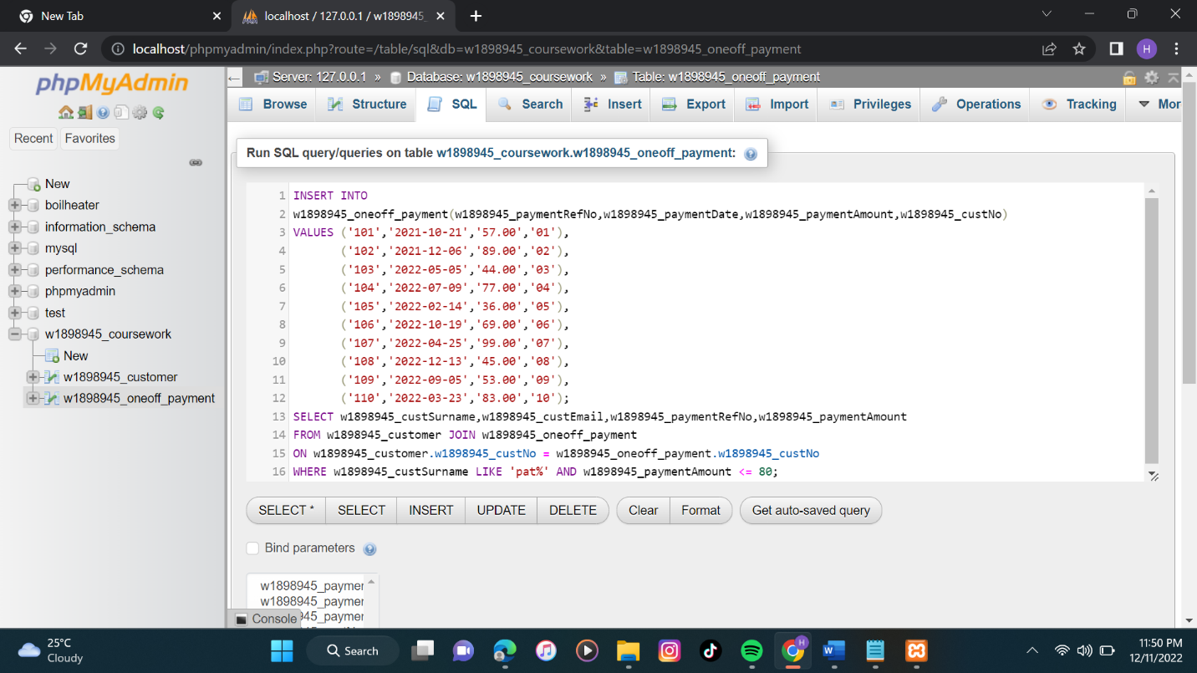

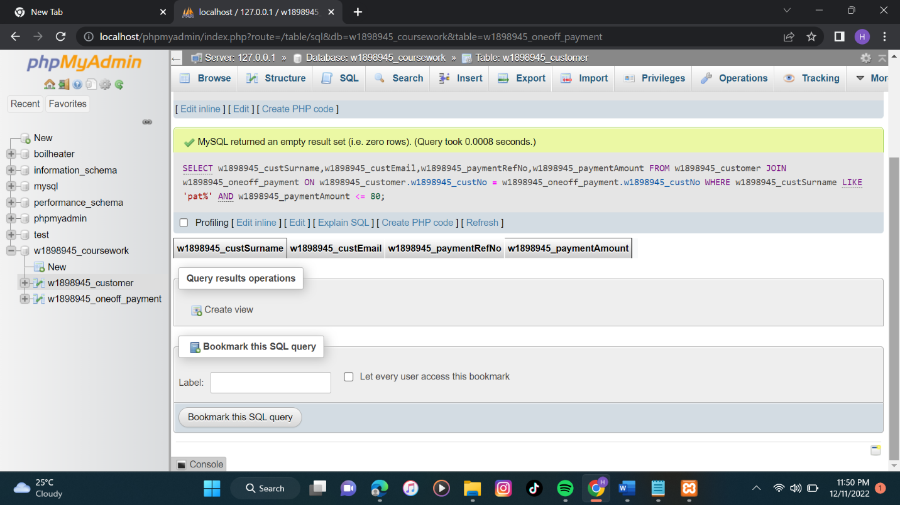

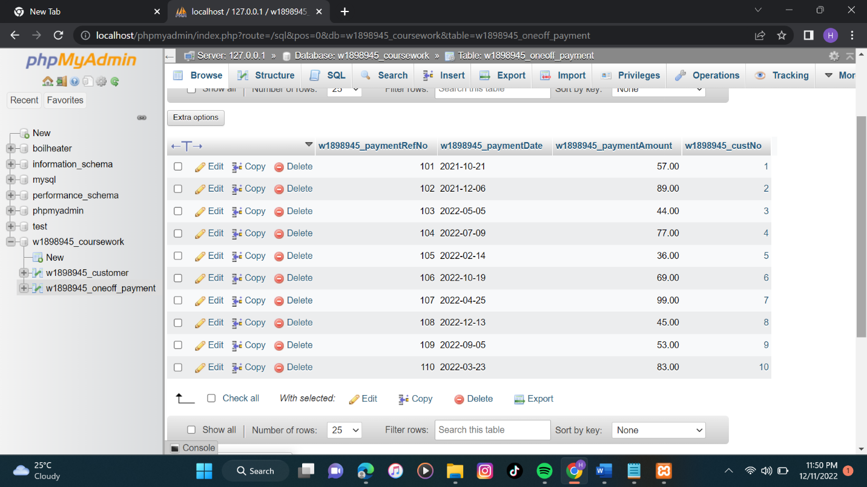

**7.SQL Query to select the records with the given conditions.**

Code>SELECT w1898945_custSurname,w1898945_custEmail,w1898945_paymentRefNo,w1898945_paymentAmount

FROM w1898945_customer

JOIN w1898945_Oneoff_payment

ON w1898945_customer.w1898945_custNo = w1898945_oneoff_payment.w1898945_custNo

WHERE w1898945_custSurname

LIKE 'Pat%' AND w1898945_paymentAmount <= 80;

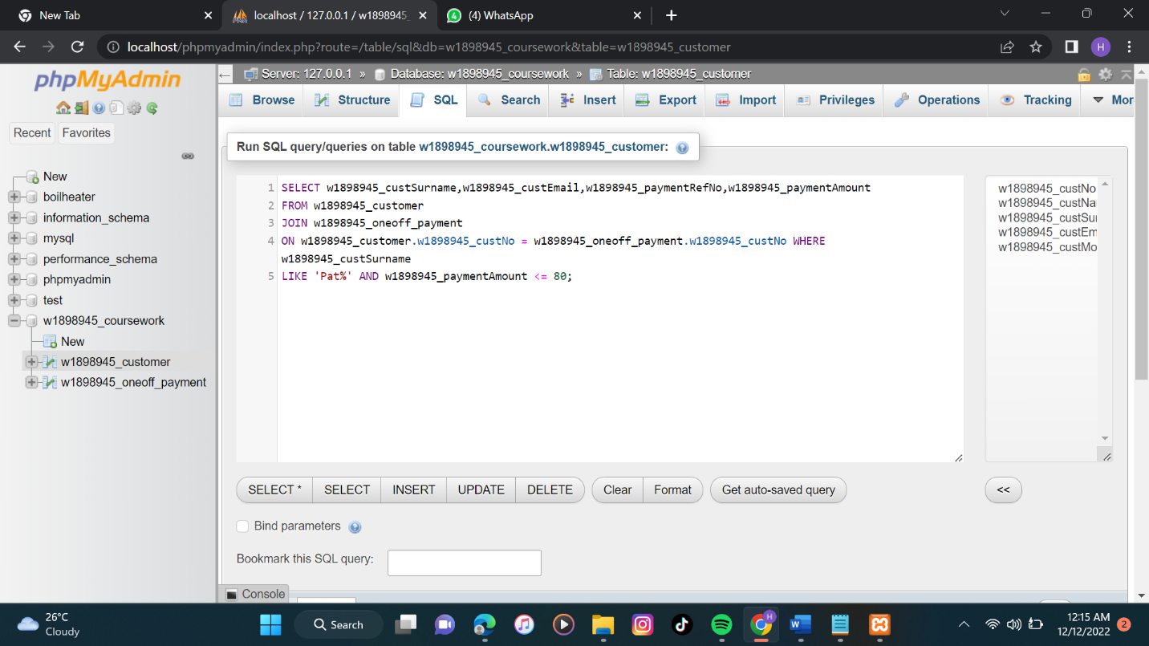

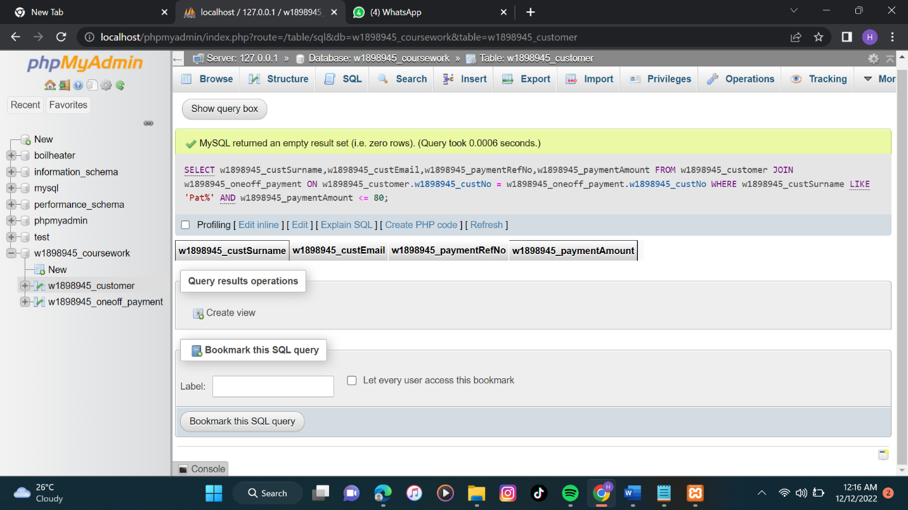

|  |  |  |
| --- | --- | --- |
| **Area** | **MySQL** | **MongoDB** |
| 1. Introduction | Organizing and storing data, MySQL is a free and open-source relational database management system.  Data in tables with associated data types using structured query language. 2022 (Acharya)  Data is kept in tabular form with columns and rows, and a different key is used for each row. (2022 Taylor) | An open-source NoSQL database management system is MongoDB. which stores and employs document-oriented methods.  Data retrieval.  Data is kept as collections of documents. (2022 Taylor) |
| 2. Schemas | In MySQL, the schema must be defined before any data is added to the database.  MySQL requires a necessary pre-establishment on how tables are built before data can be stored there.  A stable schema for the user is preferable. (Franco & Berga, 2021) | Because MongoDB permits the usage of unstructured data, users may create applications.  without previously specifying the schema.  Enables users to quickly integrate and store various sorts of data and dynamically change the structure without experiencing any downtime.  Users can access pre-defined structures using MongoDB. Franco and Berga, 2021 |
| 3. Data Consistency. | Data consistency in MySQL is high as data duplication does not happen. | Data consistency in MongoDB is relatively low-level. |
| 4. Storage. | Rows and columns make up tables in which MySQL stores data.  Every data connection adheres to a rigid logical organization. (Meher, 2021) | Data is kept as documents and collections in MongoDB.  Collection includes written materials.  This has key-value pairs representing the basic data components. (Meher, 2021) |
| 5. Performance. | MySQL performs great in transactional operations. | MongoDB performs better on unstructured data as it is based on document-based system. |
| 6. Workload. | For high-performance joins across several tables, MySQL is designed. (Anon., 2022)  MySQL can map intricate data relationships | MongoDB's writing speed is comparatively quick. (Anon., 2022)  Data-wise, MongoDB is superior.  data mining and analysis. |
| 7. Security. | MySQL offers standard security measures such as normal encryption for the community edition. For enterprise edition it provides more security features such as authentication, TDE, masking, firewall etc. (Anon., 2022) | MongoDB provides security features like authentication, access control (user, role-based access control), and encryption (TLS/SSL) for sensitive data. (Anon., 2022) |

**REFRENCES**

Jose, B. and Abraham, S., 2020. Performance analysis of NoSQL and relational databases with MongoDB and MySQL. *Materials today: PROCEEDINGS*, *24*, pp.2036-2043.

Patil, M.M., Hanni, A., Tejeshwar, C.H. and Patil, P., 2017, February. A qualitative analysis of the performance of MongoDB vs MySQL database based on insertion and retriewal operations using a web/android application to explore load balancing—Sharding in MongoDB and its advantages. In *2017 International Conference on I-SMAC (IoT in Social, Mobile, Analytics and Cloud)(I-SMAC)* (pp. 325-330). IEEE.

Acharya, D. P., 2022. MongoDB vs MySQL: Which Is the Better Database Management System?. Kinsta, October. Anon., 2022. MongoDB Vs MySQL: Know The Difference. interviewbit, August. Berga, M. & Franco, T., 2021. MongoDB vs MySQL: what are the differences?. February. Meher, E., 2021. MongoDB vs MySQL Performance: 7 Critical Differences. HEVO, December. Taylor, D., 2022. What is MongoDB? Introduction, Architecture, Features & Example. Guru99.